W1 PRACTICE
HOMEWORK

 What is mandatory , what is optional ?
- Exercise 1 is mandatory
- Exercises 2 and 3 are optional is you want to practice more or to go further

 What do you need to be able to do for next week?
- Identify the type of variable
- Manipulate nullable and non-nullable variables.
- Differentiate between final and const.
- Manipulate strings, lists, and maps.
- Use loops and conditions to control flow.
- Define and call functions with positional and named arguments, understand arrow syntax



 Are you lost?
Read the following documentation to be ready for this practice:

- Variables
- Null Safety
- Built-in types
- Lists
- Loops
- Conditions
- Functions

EX 1 – Find students who passed {MANDATORY}
Write a Dart program that takes a map of students and their scores and returns the names of all students who passed.
Given
- You are given a Map<String, int> where:
  - The key is the student's name.
  - The value is their exam score.

- A student passes if their score is 50 or higher.

INPUT
{
"Dara": 78,
"Sokha": 45,
"Lina": 62,
"Vanna": 39,
"Mony": 85
}

OUTPUT
[Dara, Lina, Mony]

Requirements
- Write a function:
List<String> getPassedStudents(Map<String, int> scores)

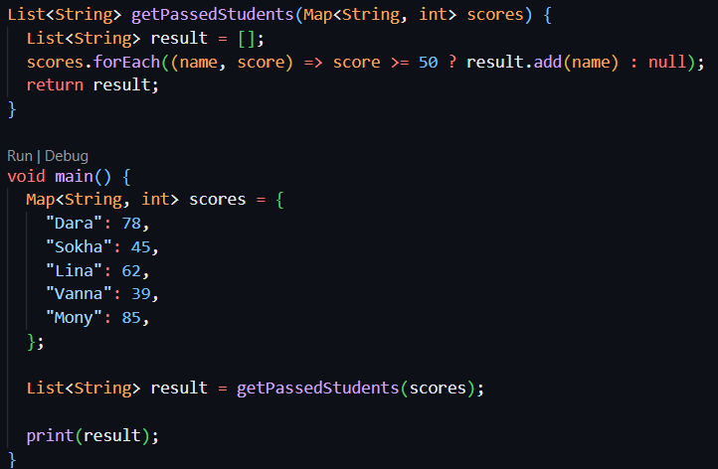

EX 2 – Compute courses averages {OPTIONAL}

Write a Dart program that takes a list of students and their scores for different courses, then displays the average score for each course.

Given
Each student is represented by a Map<String, int> containing:
- The student's name.
- Their score for each course.

INPUT
final students = [
{
"name": "Dara",
"Dart": 70,
"Flutter": 80,
"Database": 60,
},
{
"name": "Sokha",
"Dart": 50,
"Flutter": 90,
"Database": 70,
},
{
"name": "Lina",
"Dart": 80,
"Flutter": 70,
"Database": 90,
},
];

OUTPUT
Dart: 66.7
Flutter: 80.0
Database: 73.3

Requirements
Divide this work into 2 steps !!

- Write a function to compute an average from a list
double computeAverage(List<int> scores)

2. Process each course
In main: we have created a list containing the course names.
For each course:
- Create a List<int> containing the scores of all students for that course only.
- Pass this list to computeAverage().
- Display the course name and its average.

void main() {
final students = [
{
"name": "Dara",
"Dart": 70,
"Flutter": 80,
"Database": 60,
},
{
"name": "Sokha",
"Dart": 50,
"Flutter": 90,
"Database": 70,
},
];
final courses = ["Dart", "Flutter", "Database"];

// TODO: Implement computeAverage()
// TODO: For each course:
// 1. Create a list of scores
// 2. Compute the average
// 3. Display the course name and average
}

